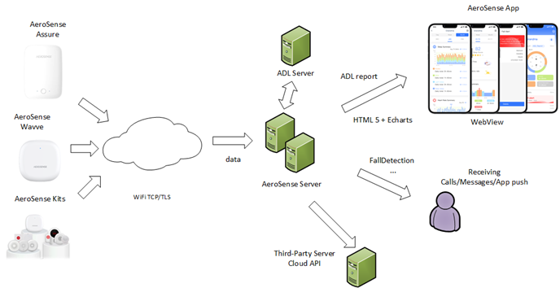

Cloud server type: load balancing server
CPU: 8-core
Memory: 16G
Disk capacity: 500G
Bandwidth: 2M (Please note that a reverse proxy is needed for the TLS, in order to uninstall the TLS of the radar TCP. The proxy radar is then connected to the real radar service in the backend. Therefore, the traffic is mainly concentrated on the proxy server, which you can dynamically scale.)
System: Amazon Linux latest stable version
The above information is based on an assumption of 10k radars. You can use different capacity if necessary.

